Mobile Assignment Two – “Flight” v1.0
Jonathan O’Brien/ITS3/jonathan.obrien@mycit.ie

App Specification

The application is a simulated flight booking system; it will require the user to select a Departure and Arrival Airport from a selection system, namely spinners. These in conjunction with a Boolean value to set whether the journey is a single or return will set up the inputs views later for taking in their relevant information, enabling or disabling them. Also inputs for the number of adult and children passengers and the class of the booking will affect the price later.

Dates will need to be chosen for the flights, will need to find a way to input these through some selection mechanism, making it a easy on the user as possible. Utilizing the date picker view will probably achieve this well.

A method will need to be devised on how to calculate the distance between airports, giving different costs depending on these values.

There will need to be some kind of credit card and address input from the user, plus authorization of this. The Previous booking will need to be placed in a form of storage system utilizing either a database or javaio, have a check if it exists and display option menu depending on this. I will use fragments to show or hide the credit card type that the user wishes to use. I will use progress bar for the authorization process. There will be a confirmation page that will show an option to enable an email with the details to be sent and a pending intent about car hire. There will also be a booking details activity, which will have multiple views switchable through flings.

I will create independent classes for storage, one to implement the storage mechanism and the other to be able to store the variables input into an object for ease of access and manipulation throughout the relatively large application.

Classes

MainFlight

Main Activity, entry point to the application. Takes in user input from Edittexts and Spinners to specify the departure and arrival airports, number of adults or children. There is and options menu to exit the program, with one menu item that only appears if a previous booking was stored to the file system. Also allows selection of single or return journey through the use or radio buttons, which will have an effect through out the rest of the application. Takes in a flight class from another spinner.

Date

Takes in the dates for the journey legs, will have some views disabled if a single journey was selected. Uses buttons with listeners to execute Dialogs with data pickers for user date selection. I also have checkbox’s, which I utilized more like a radio group as when one is selected the other is deselected.

PassangerEntry

Takes in users credit card information, including name. The credit card edit texts are only shown through buttons, which show or hide fragments with the edit texts for entry. Passing the stored inputs from the fragments to the main activity class was involved but I got it functioning. Uses a progress dialog for simulating authorization of the credit card.

PassangerEntry2

Is the address entry form for the main passenger, with the credit card. The screen is created programmatically with 4 edits texts and 3 buttons within a relative layout.

Confirmation

Shows a confirmation of the booking, does some simple calculations to give different prices depending on what previous inputs were. Has an email implicit intent which is activated by a toggle button, also has an pending intent for a car hire website.

BookingDetails

This shows the total booking details; I built the textviews contents using HTML to format the way the information is shown within the views. There are three textviews included in a view flipper; these can be navigated between using flings, left and right. There is a contextual menu on another textview above the view flipper; this is triggered by a long press. This class also stores the object containing the booking variable to file.

PreviousBooking

Same as BookingDetials class, just doesn’t store object. Used for displaying previous booking. Could have used BookingDetials again with some modification but running out of time.

Storage

Used to store, access and manipulate all variables throughout the application.

VarObjectStore

It is used to read, write, and verify the objects to storage.

1.
  - Basic functionality that addresses App’s purpose: at least 3 Activities and navigation between them. Simple UI components e.g. TextView, EditText & Button.

Completed? Yes

Edittext in MainFlight

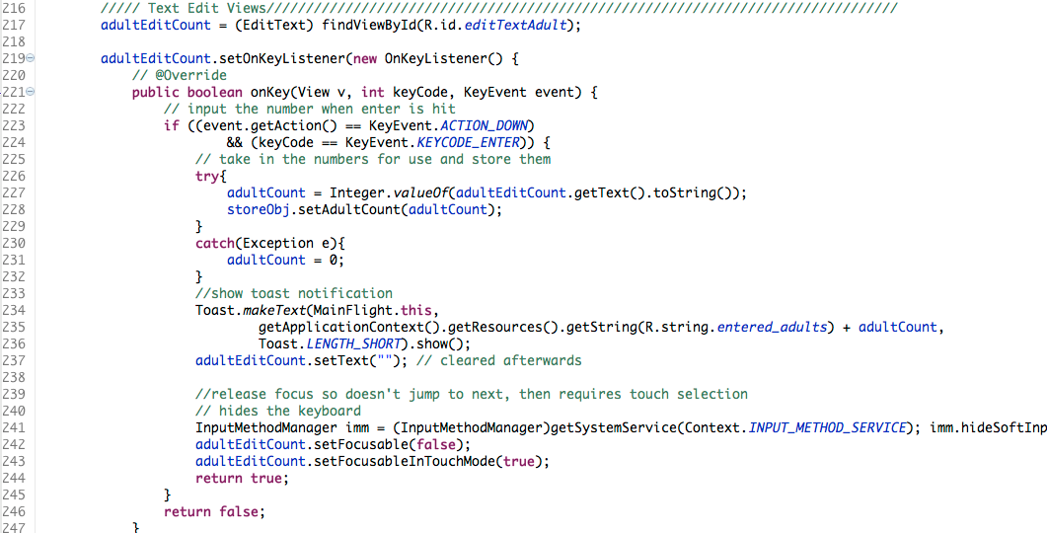

Button in mainflight

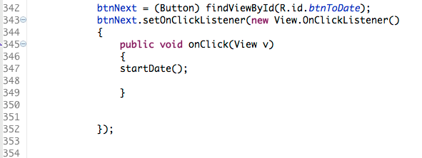

TextView in MainFlght

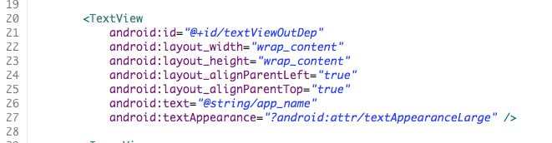

Application screen shot(s) for 1(a)

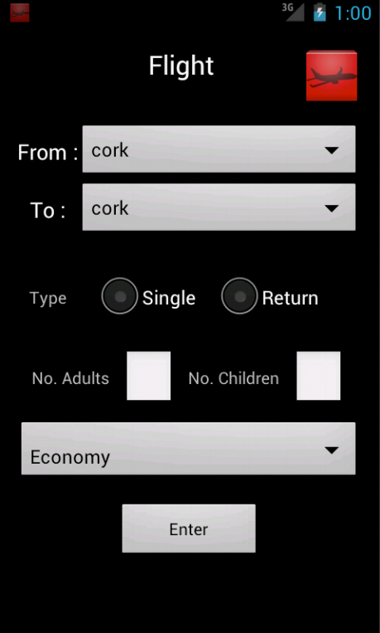
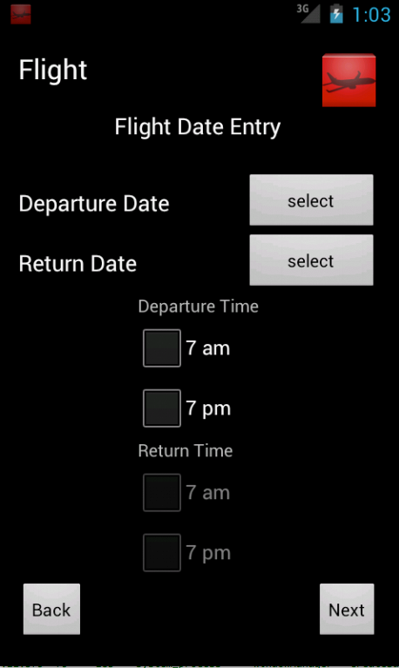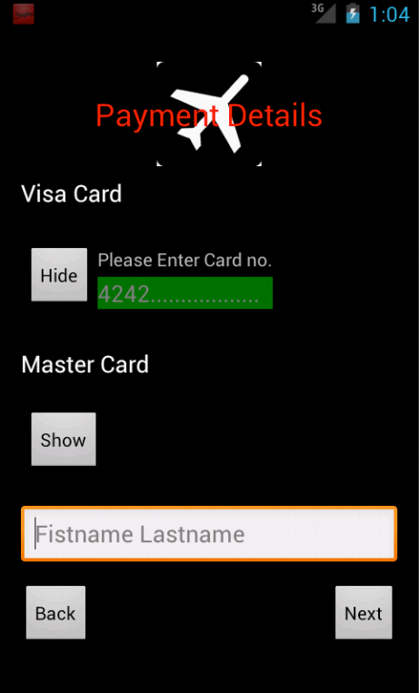

  - Use of 5 different layout managers e.g. LinearLayout H, LinearLayout V, TableLayout, RelativeLayout, FrameLayout etc.
Completed? Yes

Layout MainFlight

Has Linear Layout Vertical and Horizontal and Relative Layouts.

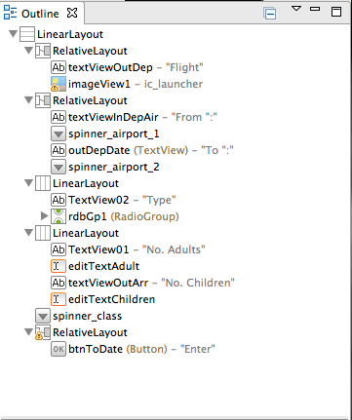

PassangerEnrty

Has a relative layout and a Framelayout.

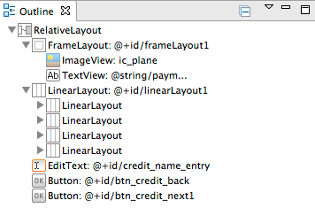

Confirmation

Has TableLayout

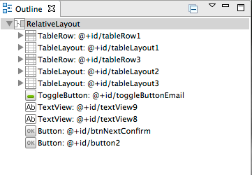

  - Use of the notification manager and a pending intent.
Completed? Yes

Confirmation Class

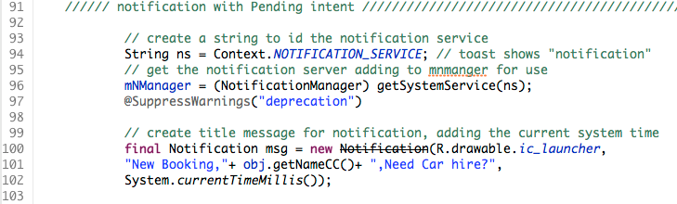

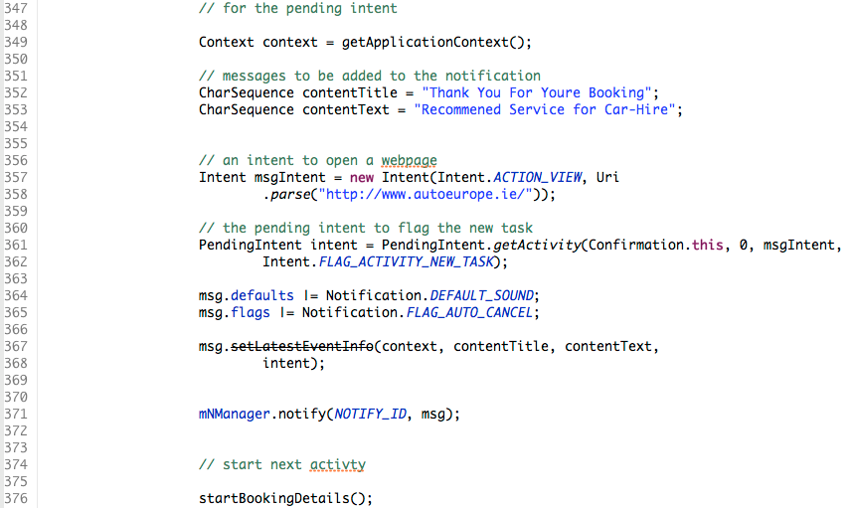

  - Include 5 different types of UI widgets e.g. e.g. Spinner, togglebutton, radiobutton, progressbar, imagebutton etc. but excluding TextView, Button & EditText.

Completed? Yes

MainFlight

Spinner

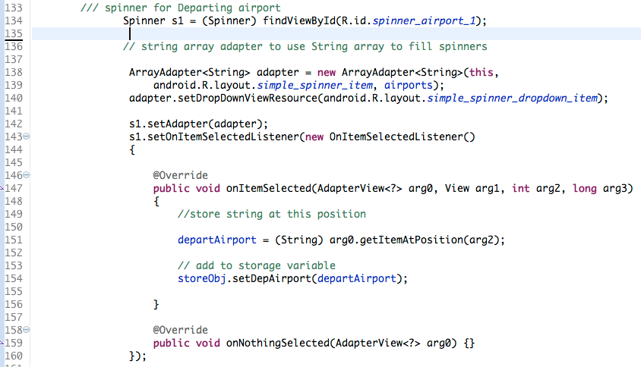

RadioButton

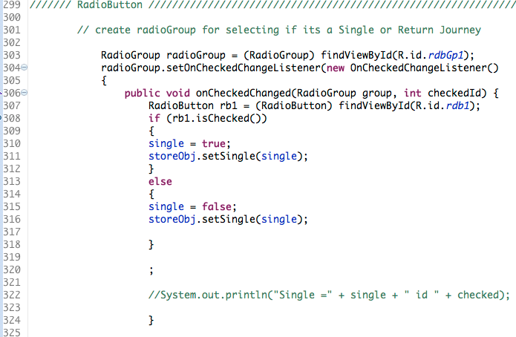

Date Class

DatePicker

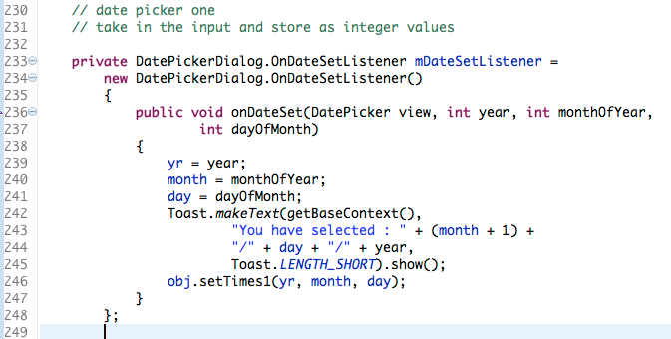

CheckBox

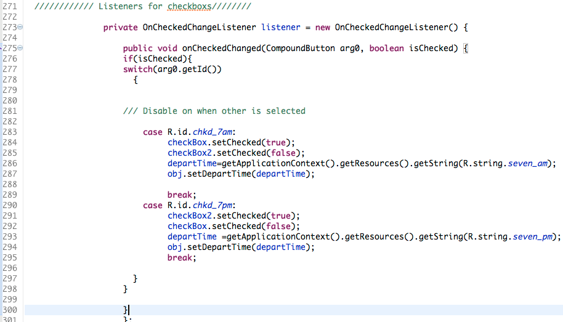

Passenger Entry class

Progress Dialog

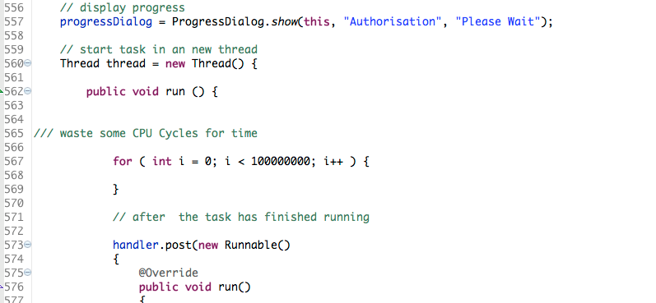

Confirmation Class

Toggle button

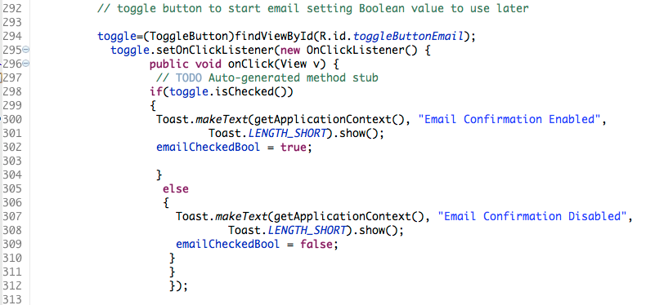

  - Menus invoked by menu button defined in XML with icons and 1 menu item shown/hidden depending on App state. Contextual menus & trigger.
Completed? Yes

MainFlight Class

Menu buttons Options

Menu and first Item Created in XML with icon.

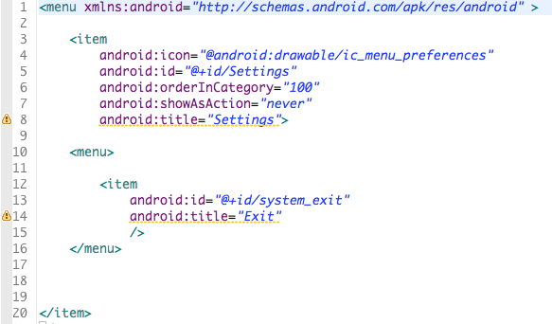

Second Menu item appended depending on app state with icon.

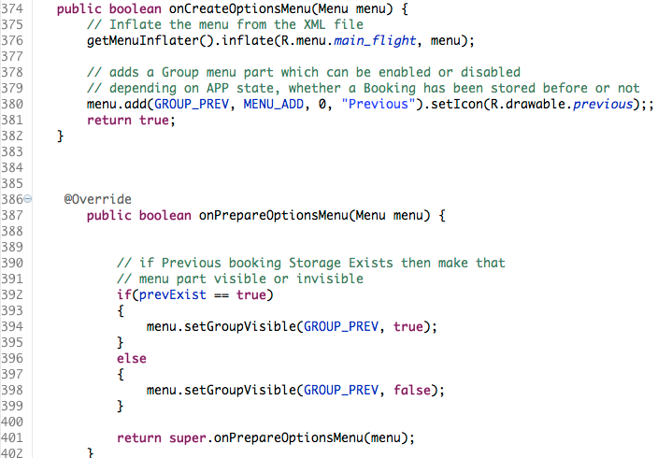

Booking details class

Contextual menu

Contextual Menu connected to a text view, triggered by a long press on the Text view.

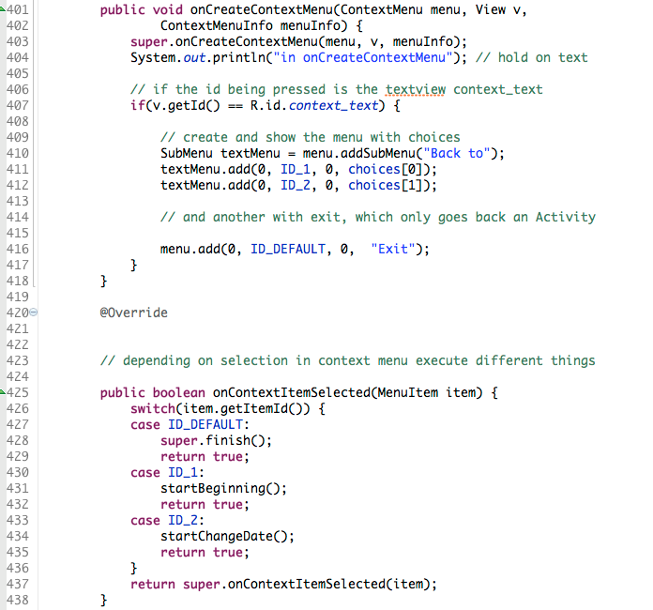

2. Three Advanced features or innovation/creativity; here are some examples but you can do different ones if you want:

  - A screen with a layout created programmatically and four widgets. Two variables saved using javaio or sql.
Completed? Yes

PassangerEntry2 Class

Screen Programmatically

One of the Views an Edit Text, there are 4 of these + 3 buttons created programmatically within the class, using a relative layout.

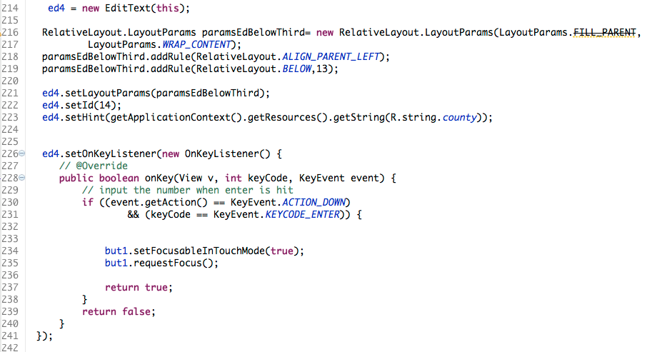

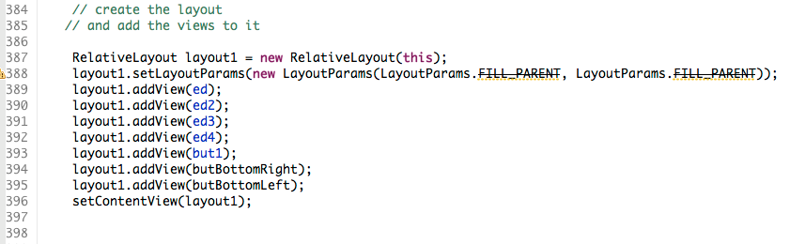

Booking Details

2 variables stored using Java IO. In this an Object is stored but it contains many, many variables. It uses the classes Storage for variables, and the VarObjectStore to read and write them to file system.



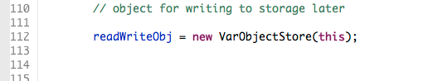

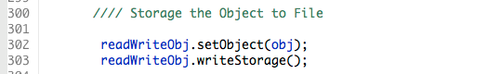

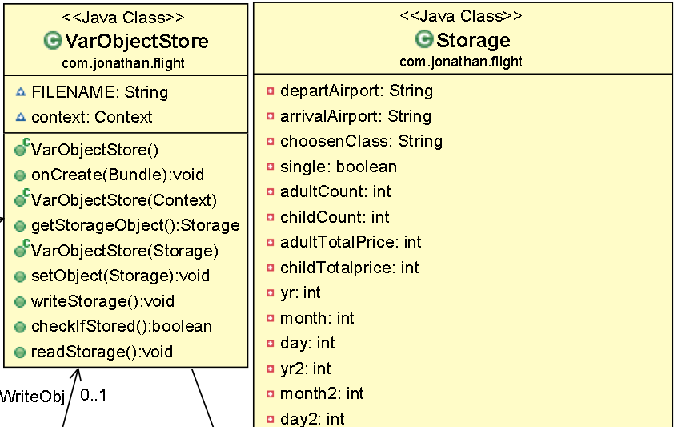

  - Gestures. Flings. View Flippers. FromHTML to format textviews.

BookingDetails Class

Flings

Flings between textviews which contents are created using HTML, the views are flipped through using a view flipper.

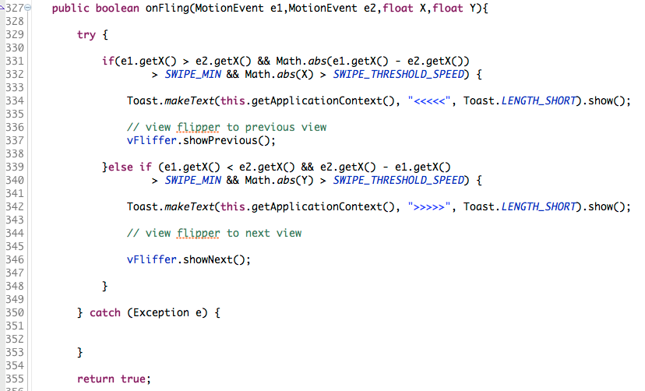

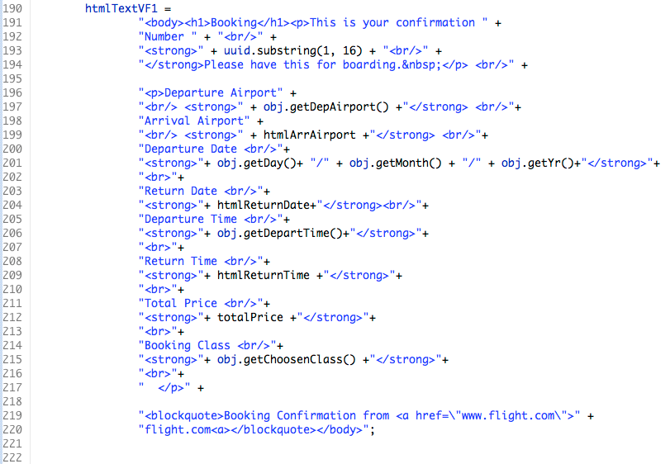

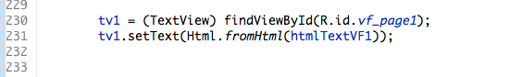

  - API functionality not covered in lectures. E.G home screen widgets, Fragments, sharing with e.g. social media
Completed? Yes

PassangerEntry Class

Fragments

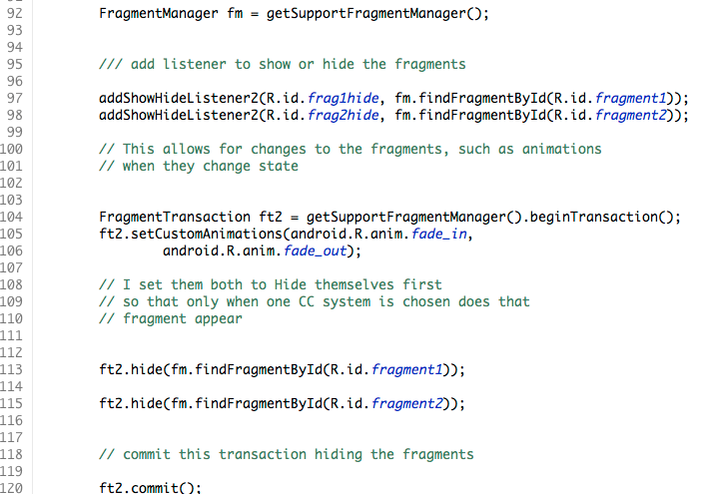

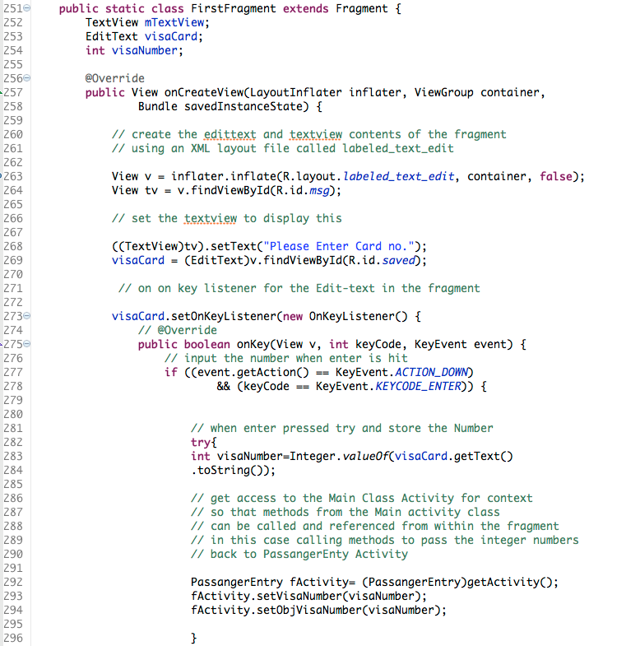

Evaluation

- How has it worked out

Worked out well enough, though I found that using an emulator With SDK lower than 14 could cause the screen to display incorrectly. The keyboard would be so far down on the screen that it was useless. I forced the App to use 14 and above because of this. With the use of Android 4.0 seemingly being the best. Also since I did not use Intents that returned a status code and value I could not exit the entire app.

- What could be done differently

The use of activity for result between all activities may have enabled me to have a cascading shutdown of the entire applications activities. I would have made it so that the application would not have accepted that the departure and return airport could be the same.
I would have tested earlier with other SDKs to make sure that there were no obvious issues that could have been better resolved in the beginning. I would have not forced the orientation of the activities and allowed them to be switched, with the appropriate XML files for this. May have used on restore to variables to activities in some fashion with a menu allowing direct change to each activity.

- Future outlook

I think that I am beginning to become more familiar with the Android platform, and would like to continue to develop for this platform in my own time. I will definitely have to research the more advanced java concepts in more depth because I am not in a programming Stream course, though I wish I were at this point.

